CRA & AB Tax Remittance Procedures
CAP DEPOSITS

Date modified 03 December 2019

V. 1.1
Contents
Version Control Change Log 2
Overview 4
Process Flow 4
Remitting Electronic Forms 4
CRA Business Tax 4
AB Finance Tax 9
Remitting Payments via Bank Draft 15
Tracking Payment Volumes 19
Reconciliation Process 21
Processing the Reconciliation 21
Auditing the Reconciliation 27
Posting example 27
Recalling a Duplicate Remittance 29
Understanding the Central1 Reports 31
Understanding Remitted and Posted Exceptions 32
Investigation Tips 32
T24 – UB Payments Enquiry 32
Auditing 34

Overview
Centralized Services Banking Support Payments team remits payments made in branch as T24’s Ebill system cannot currently remit to Central1’s Payment Stream Direct system. This is due to a number of fields required to be completed for these types of payments, and T24 doesn’t have these fields available via the EBill version on T24.
Once the branch has completed the over the counter bill payment, Centralized Service MUST remit an electronic voucher to CRA by following these procedures.

Process Flow

Remitting Electronic Forms

CRA Business Tax
Step | Instruction
1 | From shared inbox, print transaction receipt and payment stub. Review to ensure all fields are completed and legible. This includes:  - branch transit  - name of person who processed the payment at the branch  - amount  - account number  - client CIF  - form number  Reference: F10 Bill Payments > 3.7 CRA Business Taxes  Note: CRA Tax Remittance forms should be done as soon as possible, and their completion is a top priority
2 | Navigate to PaymentStream Direct (https:\\www.secure.central1.com). Enter your login credentials.
3 | Click My Work > Applications > PaymentStream Direct  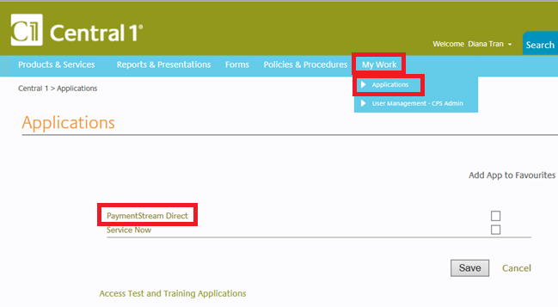
4 | Select Business Taxes from the drop-down menu.  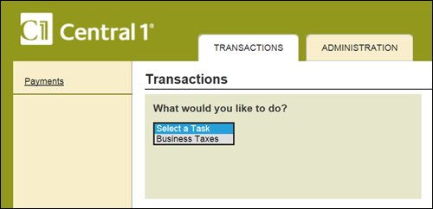
5 | Determine type of Business Tax by identifying the form number. On payment stub, form number is located in the upper right or bottom left.  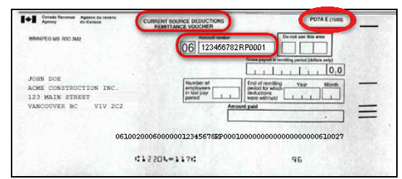
6 | Select the Branch Transit from first drop down menu. Then select Form Number from the second drop down menu. Click Continue.  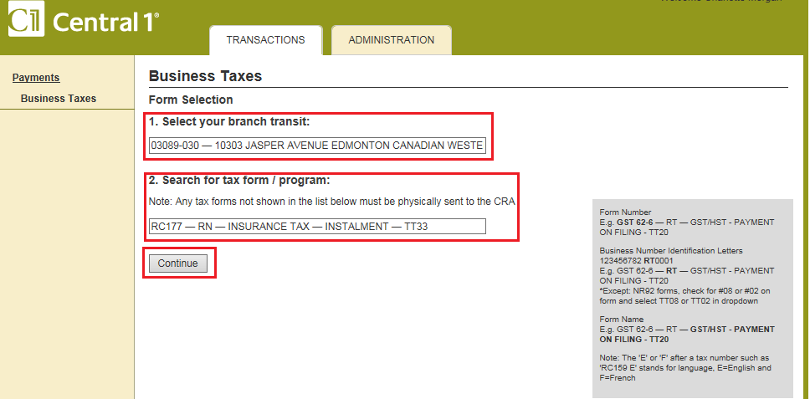
7 | Does the form number appear on the list?
  If | Then
  Yes | Continue to Step 8
  No | Go to Remit Non-Electronic Forms
8 | Complete mandatory fields which vary per form. Click Continue.  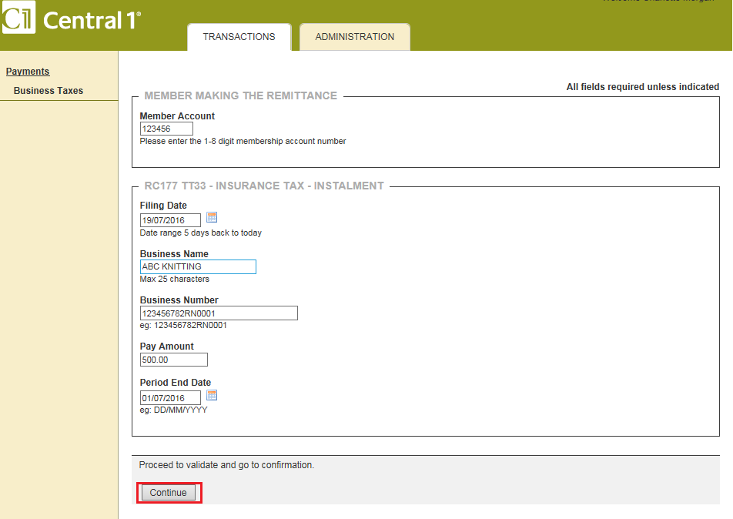
  Field | Instructions
  Member Account | Client CIF that was debited for payment
  Filing Date | Effective date of payment. CMS can back-date up to 5 days.
9 | Review the information that will be remitted. Are there any errors?  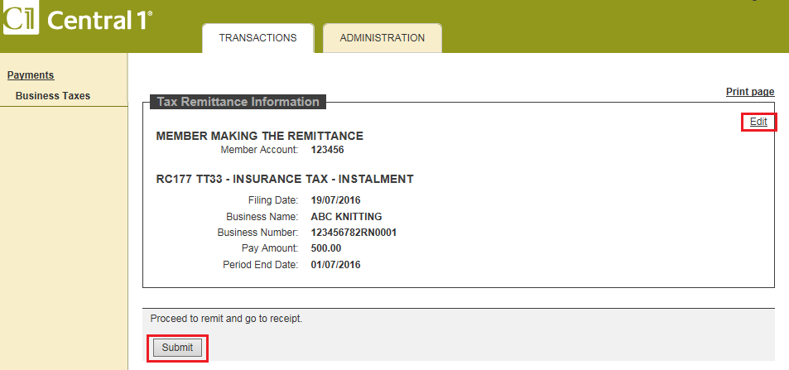
  If | Then
  Yes | Click Edit to return to input page
  No | Click Submit
10 | Print Remittance Successful confirmation screen. Ensure there is a confirmation number.  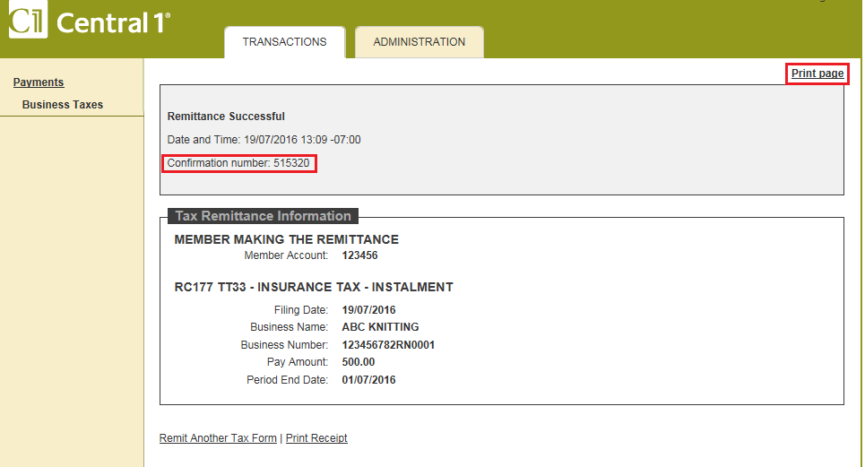
11 | Is another remittance required?  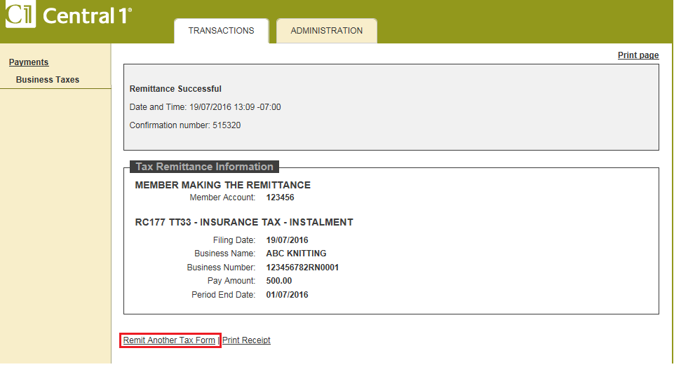
  If | Then
  Yes | Click Remit Another Tax Form and repeat steps 5 to 10.
  No | Go to step 12
12 | Give payment stub, UB Receipt & Successful Remittance Confirmation to another team member to audit. Place payment in daily payment folder.

AB Finance Tax
Step | Instruction
1 | From shared inbox, print transaction receipt and payment stub. Review to ensure all fields are completed and legible. This includes:  - branch transit  - name of person who processed the payment at the branch  - amount  - account number  - client CIF  - vendor description eg. Alberta Corporate Tax  Reference: F10 Bill Payments > 3.8 Alberta Finance Tax Payments  Note: Alberta Tax Remittance forms should be done as soon as possible, and their completion is a priority over CRA business tax remittances. Alberta Finance does not accept backdated payments.
2 | Navigate to PaymentStream Direct (https:\\www.secure.central1.com). Enter your login credentials.
3 | Click My Work > Applications > PaymentStream Direct
4 | Select Business Taxes from the drop-down menu.
5 | Determine the type of Alberta Tax by identifying the vendor description on the remittance form. Alternatively, if the vendor description is unclear, use the account number or remittance code to help determine the tax type.  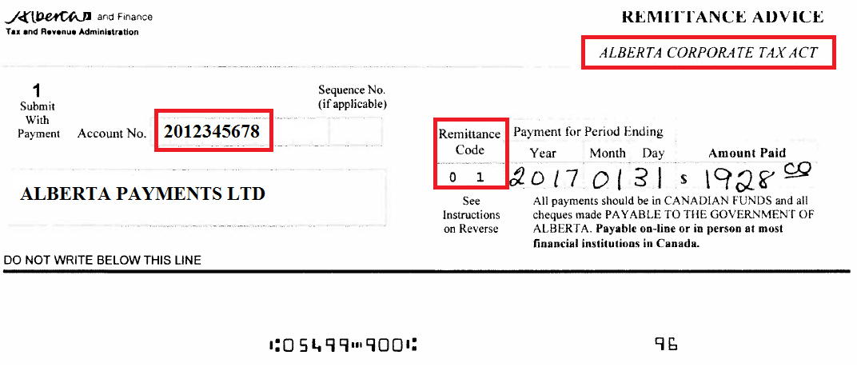
  T24 Vendor ID | T24 Vendor Name | Remittance  Code | Vendor Acct Number Format
  12339 | ALBERTA FINANCE CORP INCOME TAX | 1 | 9 or 10 digits  Begins with 2 or 8
  12341 | ALBERTA FINANCE HEALTH COST REC | 23 | 9 or 10 digits  Begins with 2 or 8
  12342 | ALBERTA FINANCE INSURE TAX PREMIUM | 3 | 9 or 10 digits  Begins with 2 or 8
  12338 | ALBERTA FINANCE 911 LEVY | 29 | 9 digits  Begins with 4  Tourism Levy Exception  If 12 digits, then  First 9 digits = account number  Last 3 digits = occurrence #
  12350 | ALBERTA FINANCE CARBON LEVY | 31
  12340 | ALBERTA FINANCE FUEL TAX REMITTER | 10
  12343 | ALBERTA FINANCE IFTA FEES | 7
  12344 | ALBERTA FINANCE IFTA PMT FOR PERIOD | 7
  12345 | ALBERTA FINANCE LOCOMOTIVE FUEL | 13
  12346 | ALBERTA FINANCE PROPANE DISTRIBUTOR | 21
  12347 | ALBERTA FINANCE TOBACCO TAX COLLECT | 11
  12348 | ALBERTA FINANCE TOURISM LEVY | 5
  12349 | ALBERTA FINANCE CARBON LEVY INV DEC | 30 | 9 digits  Begins with 3  Exception: If 12 digits, then  First 9 digits = account number  Last 3 digits = occurrence #
6 | Select the Branch Transit from first drop down menu. Then select Alberta Provincial taxes. Next, select the type of tax form from the second drop down menu. Click Continue.  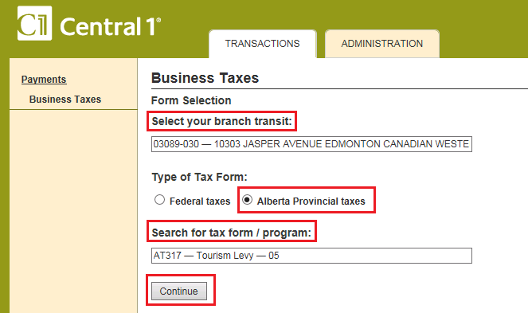
7 | Complete mandatory fields which vary per form. Click Continue.  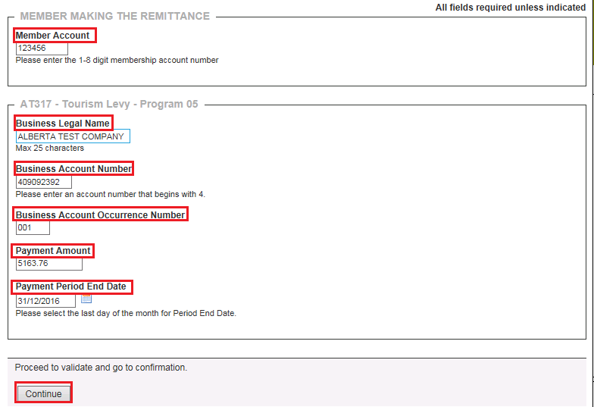  Sample remittance form  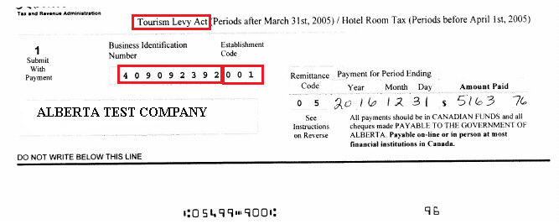
  Field | Instructions
  Member Account | Client CIF that was debited for payment
  Filing Date | Filing date = today’s date (hidden field)  Alberta Finance does not accept back-dated tax payments.
  Business Account Number | 9 or 10 numeric digits only  Exception: If 12 digits, then use first 9 digits.
  Business Account Occurrence Number | Tourism Levy only. Hidden for other forms.  Exception: If 12 digits, then use last 3 digits.
8 | Review the information that will be remitted. Are there any errors?  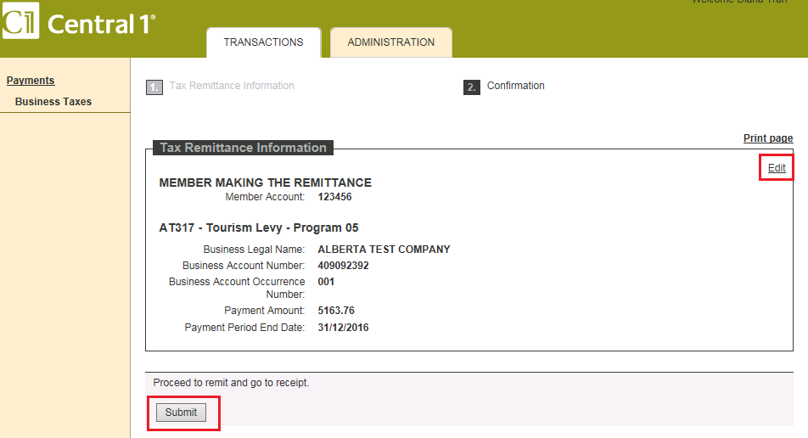
  If | Then
  Yes | Click Edit to return to input page
  No | Click Submit
9 | Print Remittance Successful confirmation screen. Ensure there is a confirmation number.  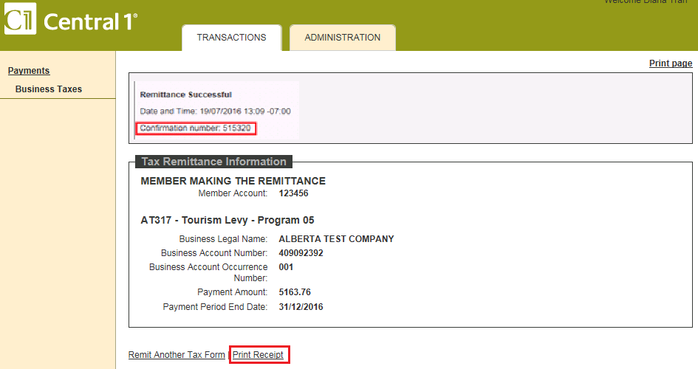
10 | Is another remittance required?  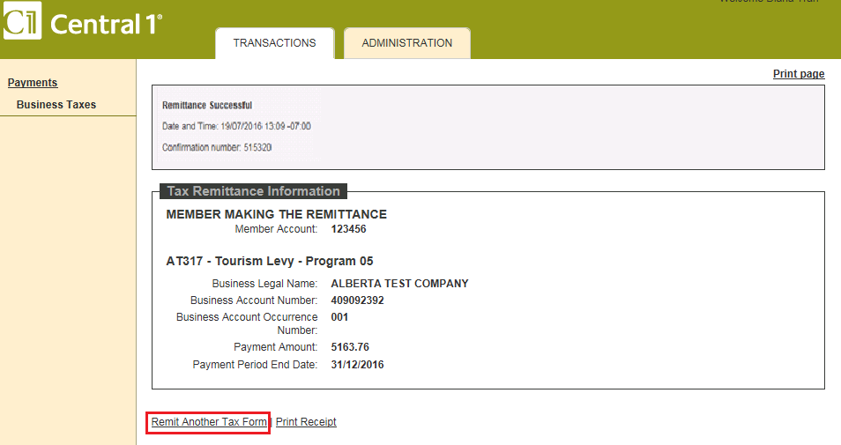
  If | Then
  Yes | Click Remit Another Tax Form and repeat steps 5 to 9.
  No | Go to step 11
11 | Give payment stub, UB Receipt & Successful Remittance Confirmation to Cash Management team member to audit.  **(INITIAL each confirmation page for Audit tracking)**

